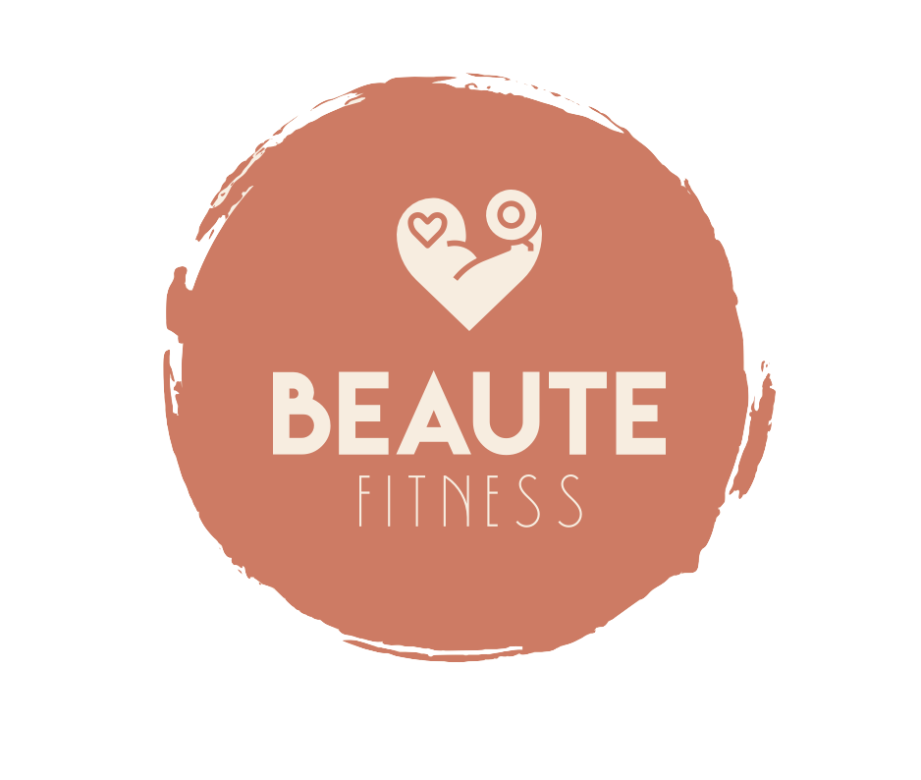

Brynn Hastie

Table of Contents
Executive Summary 3
The Business Model Canvas 4
The Business Model Canvas: Explanation 5
Project Management: Work Breakdown Structure 6
1.1 User Research 6
1.2 Technical Development 6
1.3 Testing and Implementation 6
Business Process Modeling: BPMN Model 7
User Experience: Application Wireframe Models 8
Database Management: Entity-Relationship Model 9
Entity-Relationship Model Explanation 9

Executive Summary

Beaute fitness is an app-based fitness company designed specifically for women, equipped with physical gym locations and in-app fitness features. The goal of Beaute fitness is to establish a safe and motivational environment for women to reach their health and fitness goals without the pressures that overcrowded co-ed gyms create.

Each physical Beaute fitness gym is digitally connected to our members through the Beaute fitness app. This app allows members to schedule classes, build their workouts, and track their progress by connecting their phones to the fitness machines when they use them. It also provides digital training options and health/nutrition resources.

There is an abundance of gyms in existence, but an all-female gym is highly competitive in the fitness market. Although female-only gyms do exist in today’s fitness culture, none of them boast the app-to-gym connection that our business model promotes. Most, if not all, of these gyms do not have an associated app that allows members to schedule their fitness classes, build their workouts beforehand, and track their progress during their workout. Our business model ensures that each woman that joins this gym has a fitness experience curated to their exact goals and desires. Furthermore, our app’s scheduling capabilities guarantee that the gym is never overcrowded and that there is always sufficient equipment and assistance available for every member.

The Business Model Canvas

The Business Model Canvas: Explanation

Beaute Fitness is an all-female gym that offers a digitally compatible fitness experience to women who either want to exercise around other women, want a high-quality workout experience, or simply want to work out from home. Our value-proposition states that our gym is a female-only fitness experience with gym-to-app compatibility, which provides women with a more comfortable and motivating fitness environment and gives them more control over tracking and building their workouts. These aspects of our company give women more incentive to come to Beaute Fitness over co-ed gyms.

Our revenue stream comes from monthly memberships that gym members pay, and additional revenue is generated from in-gym purchases. The key costs include salaries, utilities, marketing, software development, and partner fees. The key partnerships this company has are the fitness equipment manufacturers, refreshment suppliers, and payment providers. Our key resources are the app developers, experienced fitness trainers, and gym equipment.

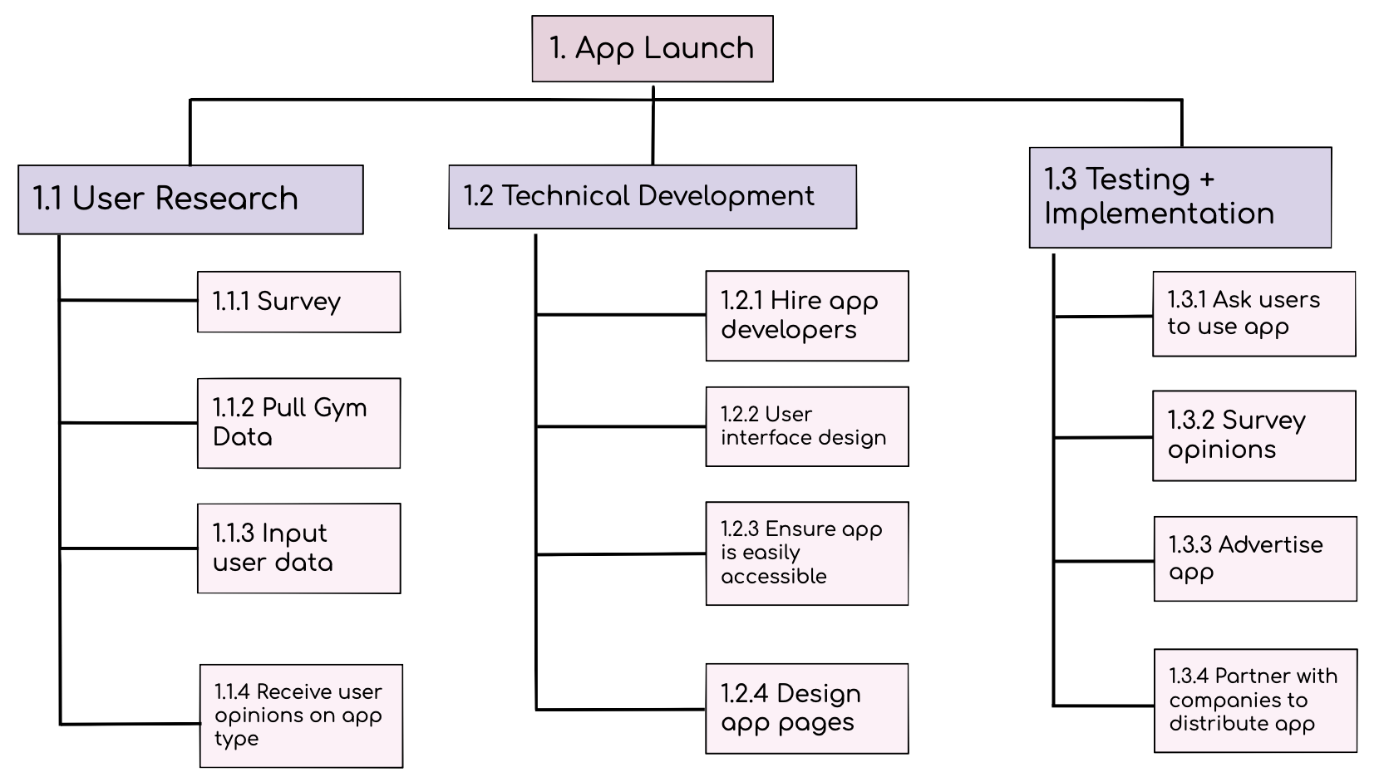
Project Management: Work Breakdown Structure

Work Breakdown Structure: Explanation

User Research
The first major step of our WBS is user research. During the user research step, we first survey the future users of the app. Next, we pull gym data, input that data, and receive user opinions on the app type.

Technical Development
The second major step of our WBS is technical development. During technical development, we hire app developers, create the user interface design, ensure the app is easily accessible, and design the app pages.

Testing and Implementation
The third major step of our WBS is the testing and implementation of the app. During this phase, we ask users to test out the app, and after surveying their opinions, we advertise the app. Finally, we partner with companies to distribute the app.

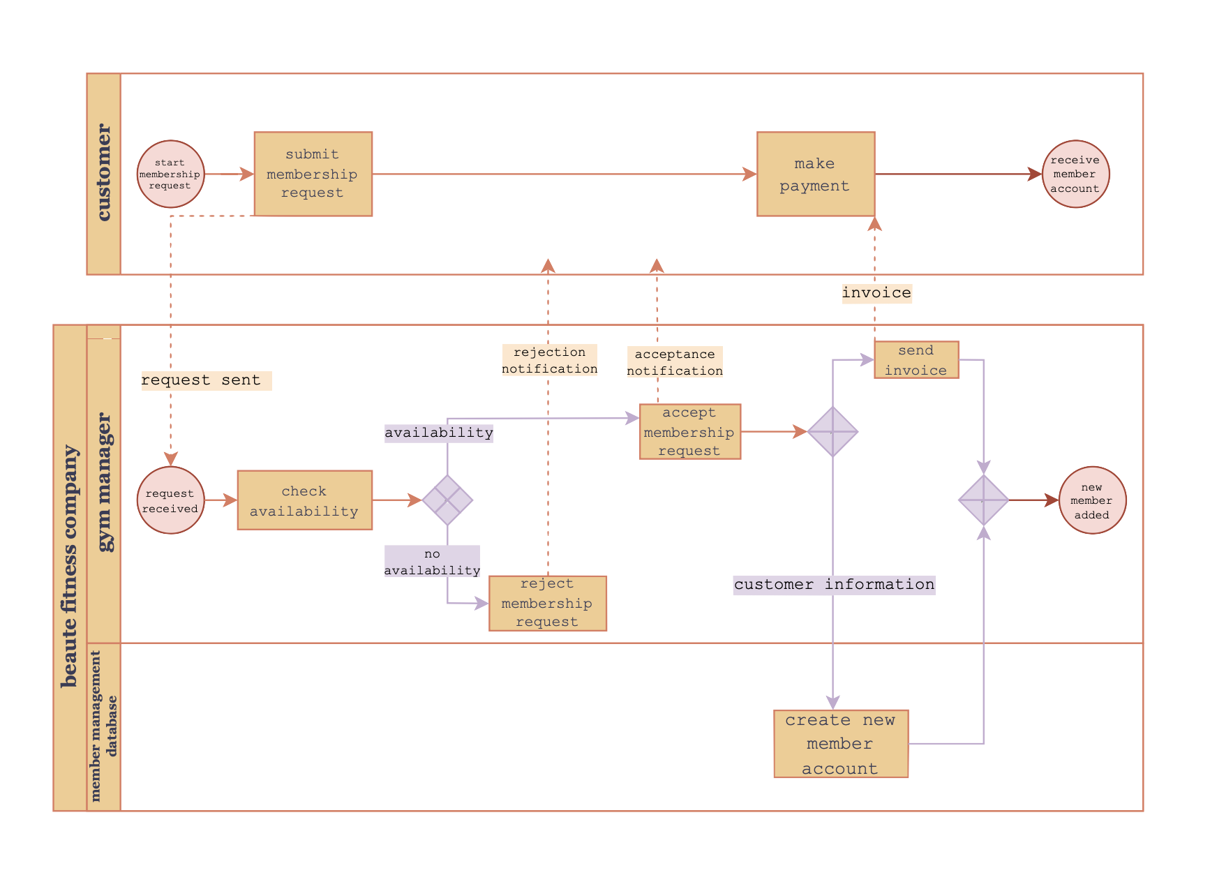
Business Process Modeling: BPMN Model

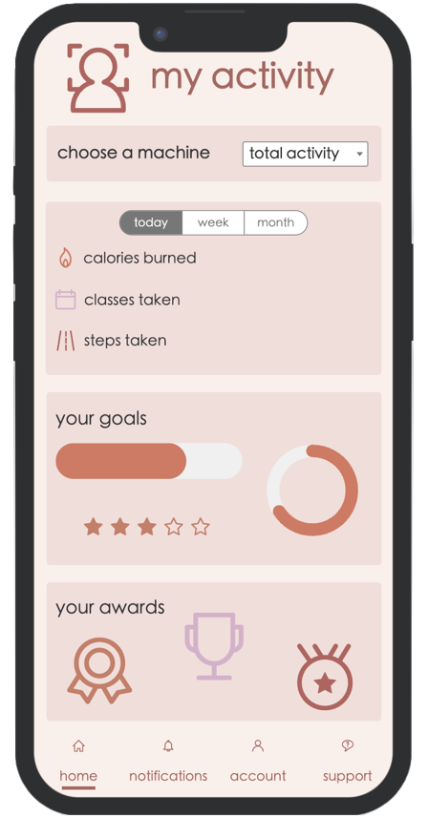
User Experience: Application Wireframe Models

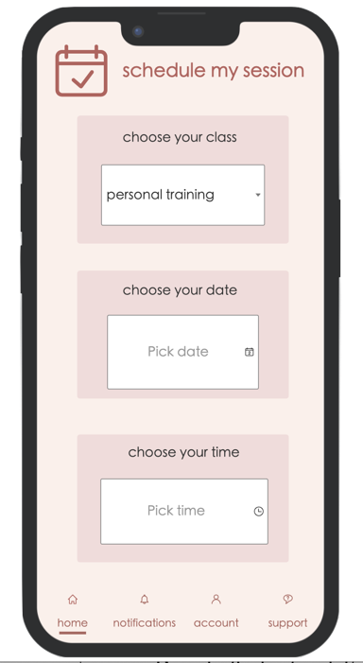
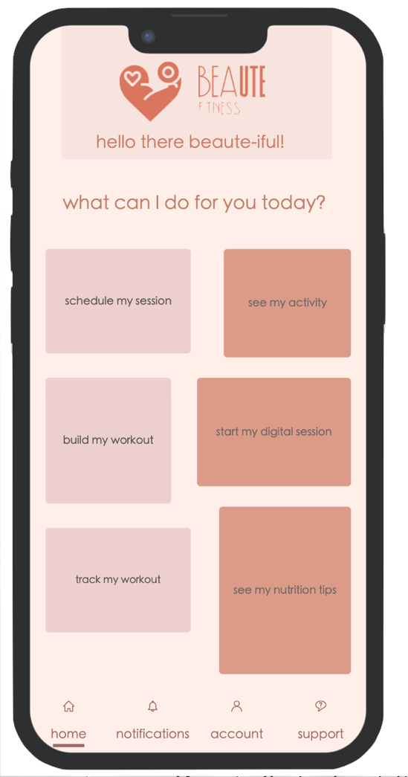

Database Management: Entity-Relationship Model
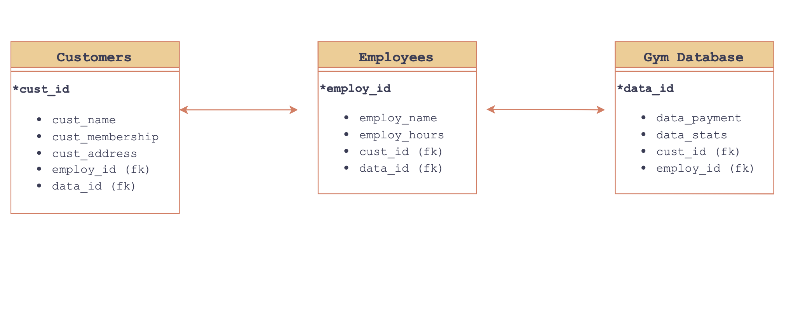

Entity-Relationship Model Explanation

The Entity-Relationship Model is a crucial part of Beaute Fitness, as we have 3 separate relationships that are all related to each other.

First, we have customers (cust_id) because without the customers, the company would fail. Within the customer entity we have different attributes such as cust_name, cust_membership, and cust_address. These attributes allow us to have personal information on our customers and track the type of membership they have. The primary key in this attribute is the employ_id, as each employee keeps track of their customers.

Next, we have employees (employ_id). The employees are the middleman between the customers and the database. They make sure the customers are happy and along with making sure all the information within the company is correct. The attributes within the employee entity are employ_name and employ_hours. This tracks each individual employee and the number of hours they dedicate to the company. The primary key in this attribute is data_id, as the database stores the company's information.
Finally, we have the database (data_id). The attributes in this entity are data_payment and data_stats. The database makes sure the customers are paying their bills and the employees are getting paid. It also keeps track of who is working out in the gym at certain hours and who is working certain hours.

The Entity-Relationship Model shows the relationships between all the attributes and how they are connected, showing us how important every part of our company is.

